Seminar 2025 – Malmaison Hotel, Reading

Overview
After a couple of years in the North, BQSG moved South for our 2025 seminar – to the Malmaison Hotel in Reading – see detailed reports below.
We began with an interesting study visit to the Museum of English Rural Life (MERL) and then were then treated to some excellent presentations by speakers:
- Swaledale Quilts and Quilters:
  - Liz Nally and Kate Smith
- The Material Evidence for Catherine Hutton’s Patchwork practice:
  - Dr Bridget Long
- Elizabeth Hake (1890-1987): Research, Publication and Legacy:
  - Dorothy Osler
- Abertridwr Quilts:
  - Katherine Gough
- “A Matter of Style”:
  - Sandi Lush
There were also brief presentations relating to BQSG Reasearch Groups (for more details see Groups page:
- After many years, Anne Jeater and Maxine March presented a summary of their work, and asked for a volunteer to take over the Signature Quilt Group; Julia Freeland agreed to take this on.
- Carolyn Gibbs presented brief details of a new Fabric Dating Group, and asked for volunteers to join her in a project to transcribe some dye record sample books written by Thomas Comstive in the early nineteenth century.
We also enjoyed seeing various items brought for a Show & Tell.
A ‘Newby’ at BQSG Seminar, Reading 2025
Back in May/June, I was thrilled to have been able to book a place to attend the Seminar, expecting to have found it fully booked as I had joined the QGBI only a month or so earlier. However, despite having been a quilter for many years, I was slightly apprehensive as the Seminar date drew near as to whether I would be out of my depth in the presence of so many experts. I definitely did not need to have worried as, on arrival, everyone was so friendly and welcoming that I immediately felt part of ‘the gang’!
The weekend with museum visit and full timetable of lectures was an absolute delight. Although I soon realised that I was definitely NOT out of my depth, I still found plenty to learn on various topics from the experts in the group. I was also quickly encouraged to submit an abstract for a presentation at a future seminar based on my previous research experience and a specialist interest. I think this will definitely be a case of ‘watch this space’! See you all again in 2026.
Cheryl Hart

Museum of English Rural Life – Study Visit

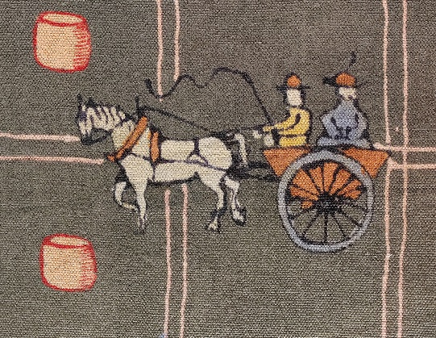
The MERL has some 30,000 items collected from around the country and includes a small collection of quilts and coverlets which we were privileged to see. The first stop that our guide, Ollie Douglas, took us to was a huge textile created by Michael O’Donnell for the Festival of Britain in 1951. This depicted scenes of rural life in Cheshire and was created using a wax-resist technique, like batik. It had delightful vignettes of scenes such as three ladies having tea on the lawn outside a half-timbered house, along with some stylised trees whose leaves were clearly sycamore, oak and horse chestnut.

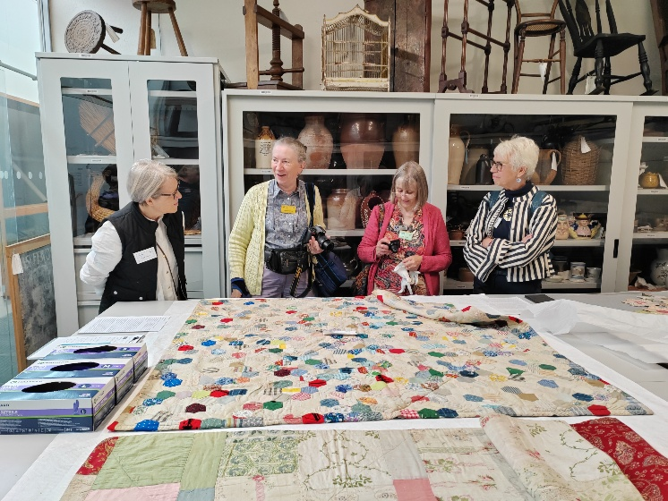
While one group looked around the collection of farm carts and implements, Ladybird books, smocks and bonnets, the other was able to see and handle (thanks to thoughtfully provided gloves) a number of quilts and coverlets. Two hexie patchworks contained a wealth of fabrics, both dress cottons and shirtings, and it was curious to see how the maker had fussy-cut some patches but had made no attempt to align them in the final rosettes. The papers in the hexies indicated a 19th century origin. A third quilt, backed with a turkey-red paisley printed design, was made from random rectangles of fabric, including cottons and satin/silks. In the roller racking were several more quilts/coverlets of silk hexies with a black background, much more luxurious fabrics than the utilitarian rectangle one.
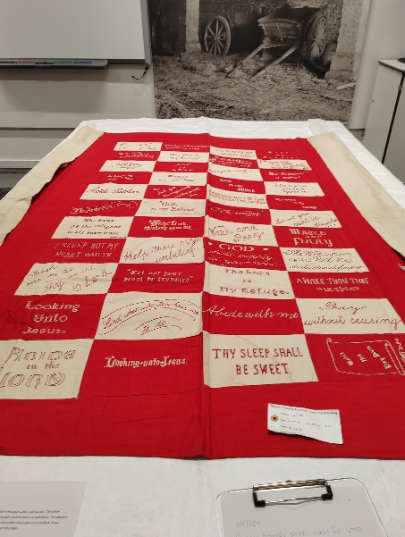
From their RIB (Rural Industries Bureau) archives two wholecloth quilts, one white, one beige, had been chosen for us to examine more closely, gloved hands turning the quilts over to assess how the edges had been made. Both of these quilts were from Blaina in South Wales, one of the areas in which the RIB was active. With their carefully balanced patterns and exquisite stitching, both of these quilts were superb examples of the output of the quilters under the auspices of the RIB.

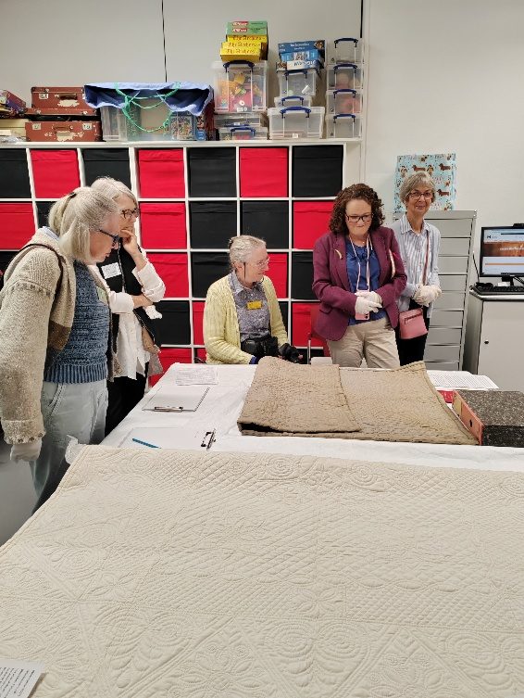
Two utilitarian and evidently well-used log cabin quilts showed sharp contrasts in style and workmanship, being well used with worn strips. One had an intriguing fabric which mimicked ikat, but thanks to Carolyn Gibbs’ digital camera we were able to zoom in on the warp and weft and determine that it was printed rather than woven.

A final coverlet was a red and white coverlet of rectangular blocks, each of which had a religious quotation embroidered on it – THY SLEEP SHALL BE SWEET, Abide with me, Pray without ceasing. It was evident that different hands had undertaken the embroidery and many different styles were used. An intriguing piece.

All in all it was a splendid visit, and members who find themselves in Reading would probably enjoy the exhibits. For those wishing to see the quilts, it is advisable to make a booking by contacting the Museum at merl@reading.ac.uk or via their webpage https://merl.reading.ac.uk.

Linda Lane Thornton

Swaledale Quilts and Quilters: Liz Nally and Kate Smith

We were treated to a very informative and detailed talk about the tradition of quilting in Swaledale. Liz and Kate had looked back into the 19th and 20th centuries, finding a rich seam of historical evidence and physical evidence in the form of 27 quilts.

Books about Swaledale by M Hartley, John Ingilby and others formed one source of information. Further detail was found from wills and other historical documents.

Of the 27 quilts studied, one had not previously been documented. The quilts were in museums or private collections. One quilt with an unusual scallop edge was found, most were in the style of north Yorkshire quilts and no ‘typical’ style for Swaledale was identified. Sadly one quilt had been used stuffed up a chimney as a draft excluder.

It was also discovered that old quilts had been used as the wadding for newer quilts, and it was common practice for carded fleece to be used as a wadding.

The art of quilting was evidently widespread and much practiced, as there were a high number of quilts found originating from the relatively small geographical area.
Molly Brown

“I have made patchwork beyond calculation, from seven years old to eighty-five”: The Material Evidence for Catherine Hutton’s Patchwork practice. Dr Bridget Long

On our first day of Seminar, Founder Member, Dr Bridget Long, presented the above titled research paper. Bridget never fails to inspire her audience and this presentation was no exception. She discussed the life of Catherine Hutton (1756-1846) in some depth, drawing the delegates into Catherine’s life. Bridget says that Catherine was an English novelist and letter writer of some renown but was also an accomplished patchworker and quilter. As family wealth and position grew Catherine was able to travel extensively and enjoy intellectual topics. But the early death of her mother ensured that her life became one of domesticity with patchwork and quilting becoming a significant activity.

Bridget talked extensively of the images here and includes this extract:

“The two surviving examples of Catherine’s patchwork donated to Birmingham Museum Trust in 2015 have similar patchwork designs and contain some of the same printed cotton fabrics suggesting that they were probably made at around the same time in Catherine’s life. Measuring 362cms (142.5ins) square and bearing Catherine’s signature with the date of 1804. The first of the two bedcovers has a large pieced central area with the surrounding border of Broderie Perse (Cut Chintz) applique and is flat quilted with no wadding (batting).”

Elizabeth Hake (1890-1987): Research, Publication and Legacy: Paper given by Dorothy Osler

Author and Exhibitions Curator, Dorothy Osler, presented her paper on the life and work of Elizabeth Hake whose book English Quilting: Old and New was published by Batsford in 1937. She introduced her subject with the line “this is the single most important source of information on hand-quilting in the Southwest”.

Elizabeth Hake (née Burnet) was born in London in 1890, into a privileged and well-connected family. She married Gordon Hake in 1924; later he became Head of the West of England Architectural College in Bristol and the couple eventually retired to their second home in Yarcombe, a small village near the Devon and Somerset border where Hake was a member of the WI, Mothers’ Union and Budleigh Salterton Musical Society.

It is thought that Hake became interested in championing West Country quilts after attending a Rural Industries Bureau (RIB) exhibition in Bristol where she realised the beauty and skill of the work by miners’ wives displayed to a discerning audience in an exhibition setting.

Not long after this, and by chance, Hake discovered a large patchwork quilt at a local farm sale. This quilt, known as The Yarcombe Quilt after the village where it was made and where the Hake’s had their second home, is now in The Guild Collection in York.

Due to this lucky find and through the subsequent involvement of the RIB, Hake met Mavis FitzRandolph and with her guidance and support set about finding and documenting hand-quilted items throughout the West Country with the aim of writing the history of local quilting and thus setting a standard for the future.

She appealed for information through local newspapers and her WI contacts. One of her contacts was the aptly named Miss Stamp, Postmistress at Luppitt, a village near Yarcombe. Miss Stamp gave Hake, and two other ladies, lessons in quilt making; Hake was fascinated by the work and acknowledged Miss Stamp’s help in her book.

The purpose of Hake’s research was to capture so-called traditional West Country quilts and she had studio photographs taken of some of the more intricately stitched patterns where she noted their provenance on the reverse of the photograph. Hake documented 36 quilts in private hands and although only 3 actual quilts are known to be in existence to date, there is an archive of Hake research material at the Archive of Art & Design at the East Street Storehouse of the V&A.
Hake’s book was published in 1937, a slim edition of just 30 pages with black and white photographs and diagrams.

There were no references to reviews of Hake’s book immediately after its publication however, in her talk Osler suggested that a “trawl of contemporaneous textile media may yield reviews or articles”. (DO)

Hake’s research successfully proved the existence of a thriving quilting culture of skill and creativity amongst rural communities in the West Country in the 19th century.

With the interruption of WWII the book went out of print, but it was known that Hake and FitzRandolph kept in contact as FitzRandolph asked her to read a draft of her own book Traditional Quilting (published in 1954). There was also correspondence between Hake and Averil Colby in the 1950s when Hake helped with Colby’s own book, Patchwork.

Although Hake was meticulous with her record-keeping not all of her information was incorporated into her book, and it appears that much material evidence has sadly been lost.

Dorothy added a postscript to her talk by recounting a visit to Hake and her son in 1984, when Hake was in her 90s. Following this visit Dorothy had been sent various family archive documents for her research and it is most of this archive which is now held at the V&A storehouse; it was Dorothy’s hope that a volunteer/s would come forward to transcribe the database of photographs and information which represents an important cultural legacy in the history of West Country quilting.
Liz Smith
With kind assistance from Dorothy Osler

Katherine Gough’s Paper – Abertridwr Quilts
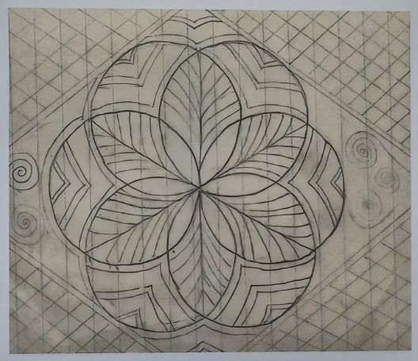
I was looking forward to hearing how Katherine’s research had progressed since last year after she shared her quilting templates in Leeds. The full collection includes carders, frames and templates. They belonged to her Welsh maternal grandmother Sarah Marion Davies (née Smith) known as Marion. She was born in 1908 and at 14 she moved to live with her Aunt Katy who introduced her to quilting, as she was an RIB secretary. (Rural Industries Bureau to encourage work in rural areas for the luxury market.) Katherine would now like to match up designs in her grandmother’s book with quilts in exhibitions and collections.
Abertridwr Rose
A letter was found in family paperwork about Marion Davies being the designer of an award-winning quilt of cream silk and wool in the 1937 Paris Exhibition. Katherine is now researching this further at the V&A East and hopes to find a photo of the quilt, and potentially the actual piece. There was also a Downing Street Exhibition in 1938 of Abertridwr Quilting Group RIB work and she would also like to see what additional newspaper reports were made other than ‘The Queen’s interest was so genuine that she bought not one quilt but two!’
Marion taught quilting for the RIB from 1938 for over 20 years. It was a long journey down the valleys to get there. She married in 1939 and her husband helped draw the designs accurately as he was a marquetry crafter. Not all the pieces were large; tea cosies, cushions and baby quilts feature – quicker to make and possibly more profitable. The children hated her teaching as they were left home alone, but it paid for their grammar school uniform. She kept a record book of the maiden names of the students, money taken etc. and this will be a useful reference point for cataloguing the locally made quilts.
Her little room had a quilt frame, 3 of her 6 children are still alive and can’t believe that she did so much there. The group eventually moved to work in the Wesleyan Chapel with more space and light. (A reminder that an indoor bathroom, water and electricity only came to her house in the 1960s.)
Amazingly in 1987 Ann Hill recorded a wonderful video of the sewing room of the ladies including Marion. They talk about having started aged 19, on 10 shillings a week. It is available in the BFI archive and Quilters Guild. Amusingly they do look to be dressed in their Sunday best rather than more unrestrictive day clothes.
A fascinating talk, highly illustrated with photos and family memories. Katherine is driven by the personal connection to this work but it will be an important addition to the national and family history too. Further research will hope to find and catalogue Marion’s work, reproduce her quilted dressing gown and locate a picture or the outfit purportedly made for Mrs Simpson.
Julia Freeland
Sandi Lush – “A Matter of Style”

Sandi made her first wholecloth in 1993 and has now made over 150 Welsh and North Country quilts. Thus, she is a designer and maker and not an historian.

Most wholecloth quilts have corner boxes in the borders, thus there is no need to turn a corner. Sandie prefers not to use too many motifs, as fewer patterns allows continuity.

Sandie took us through her process of designing several quilts, showing the changes/alterations made to the overall design and appearance. She uses a computer graphics programme, and later uses this to mark out the quilt top.

The centre must stand out. Heavy quilting will draw in the fabric by at least an inch. The Welsh quilts are more heavily quilted than the North Country ones.

Sandie had published a book, “Welsh Quilting Design” (2018) which is excellent with many design ideas. It’s the book that I would have like to have written!

Pippa Moss

