Keld Resource Centre and Swaledale Museum Stand at Muker Show 2022

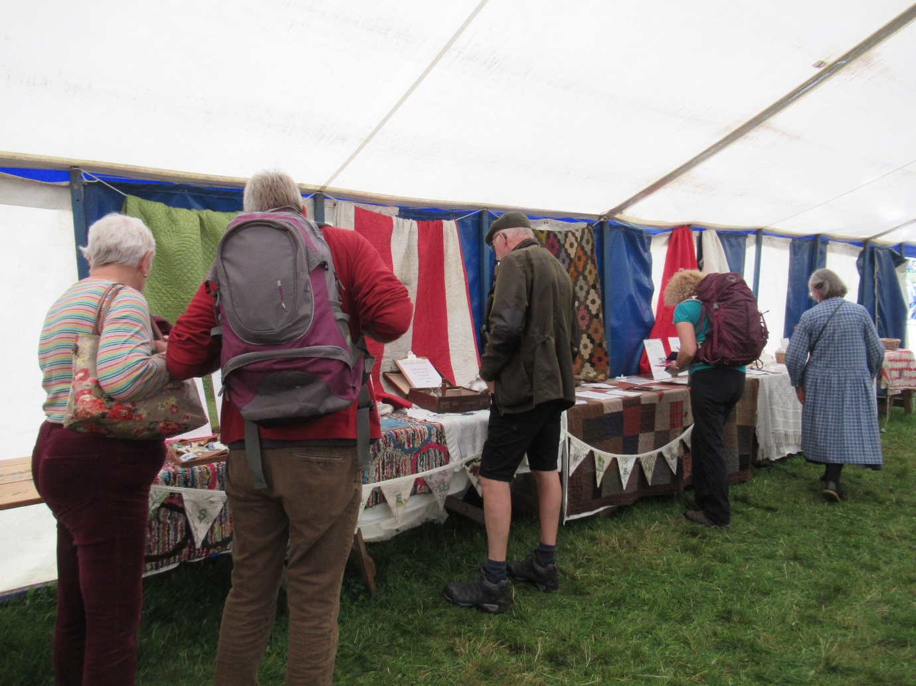
There were several quilts and other handcrafted items such as proddy rugs on display at the joint stand by Keld Resource Centre and Swaledale Museum in the Horticulture Tent at the 2022 Muker Show.
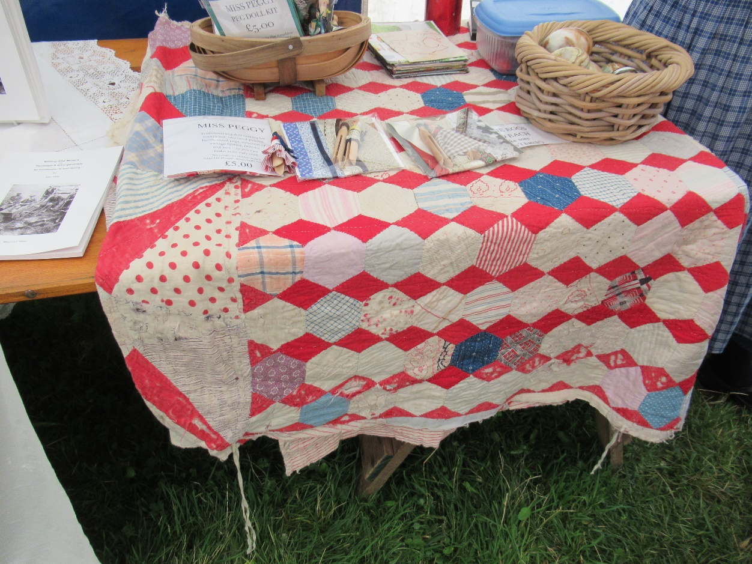

An unusual pieced design

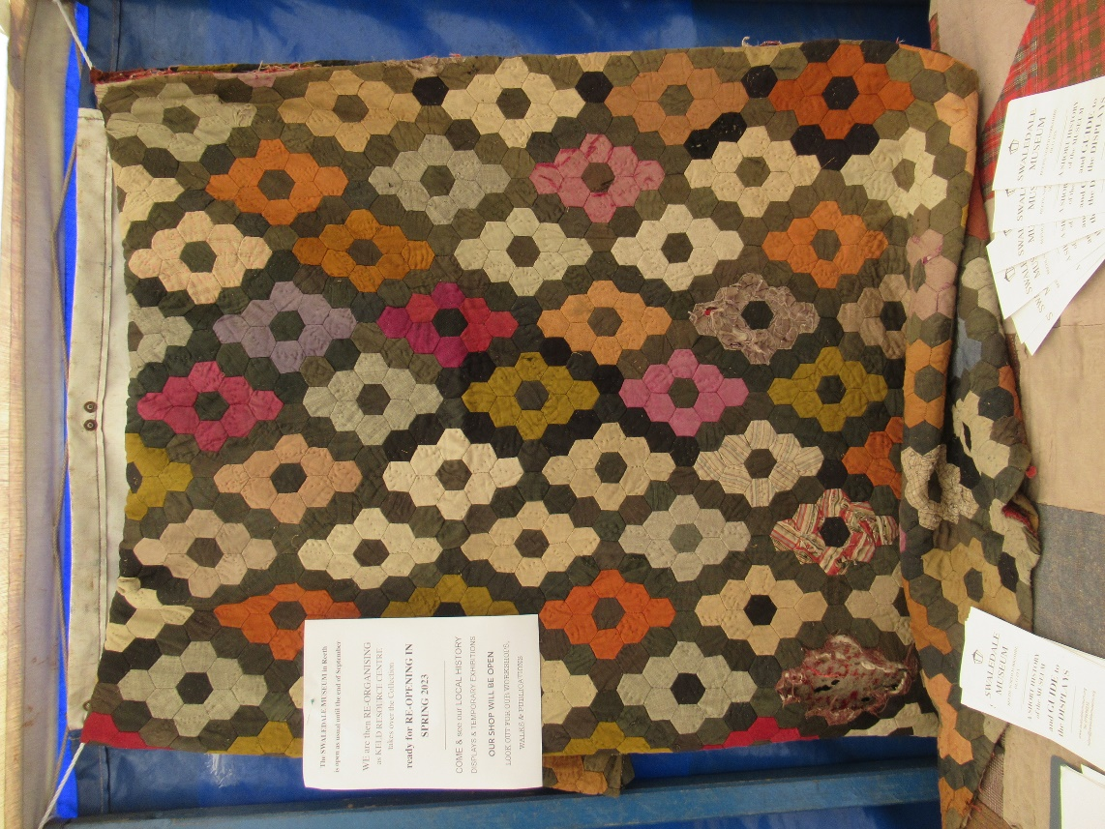

Plain coloured hexagons in a diamond layout make a striking quilt.

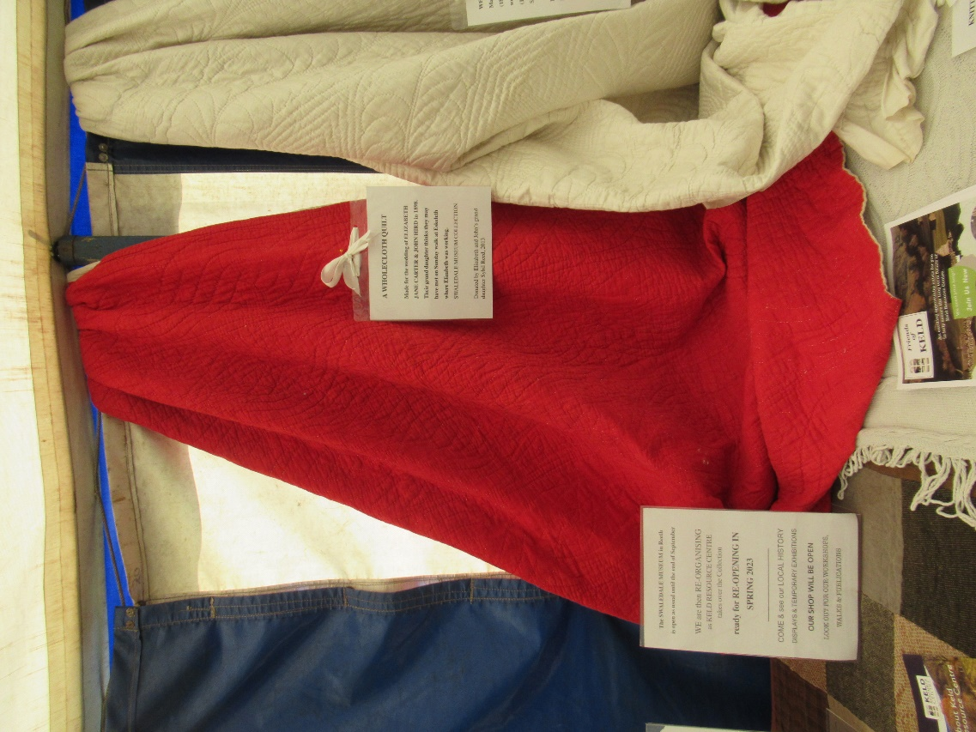

Some lovely locally made wholecloth quilts.

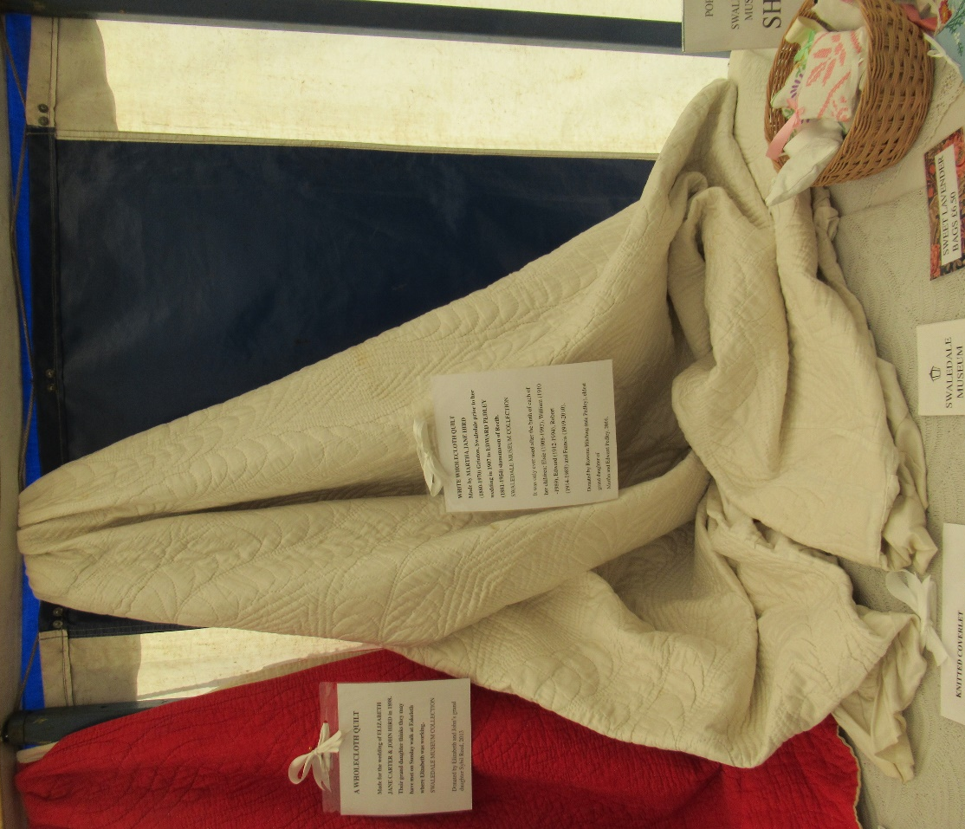

A lovely quilt made by a bride prior to her wedding in 1907

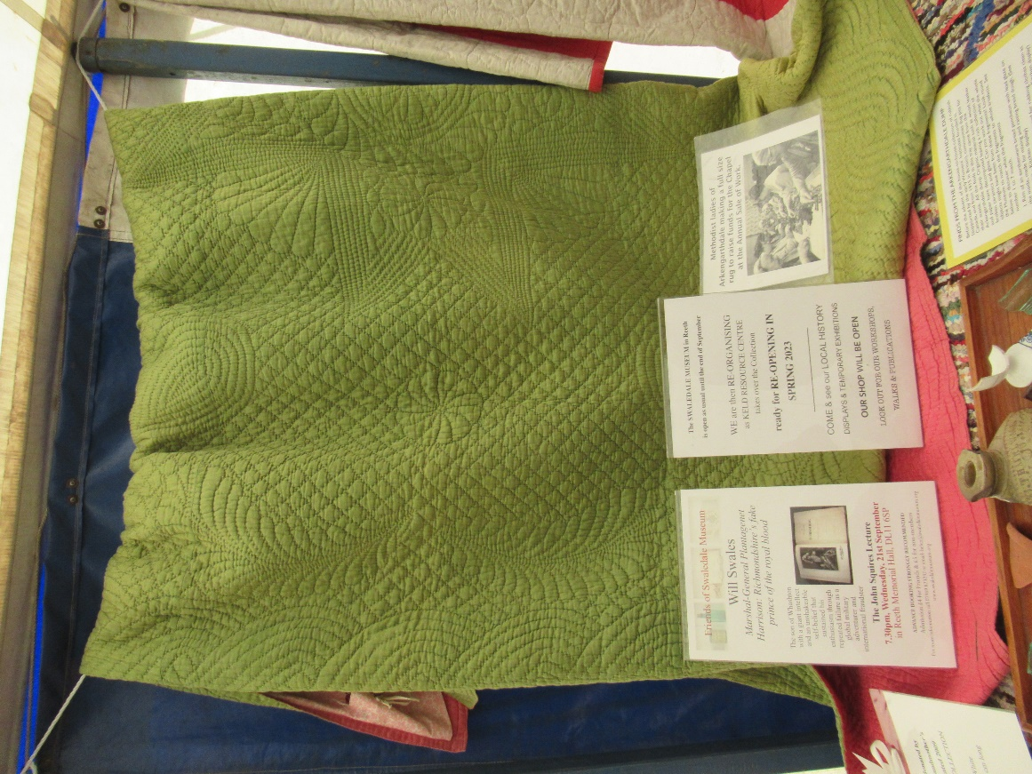
A beautiful quilt of green and pink cotton sateen made in 1898 for a local wedding.

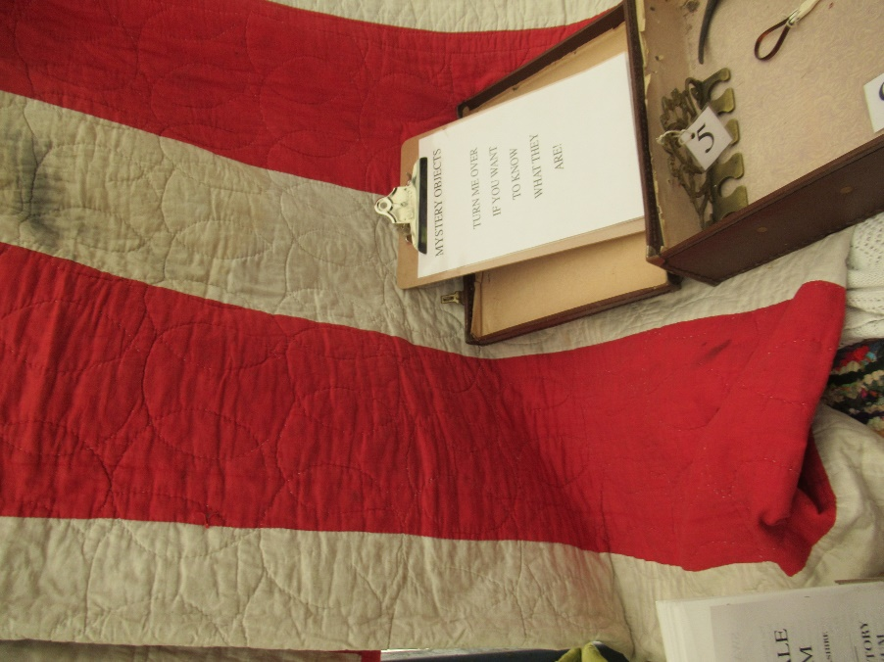

A well-used red and white strippy with a simple wineglass quilted pattern.

