

Your regional committee is looking for people to join us in the following roles…
Newsletter Editor and Website Editor-
Please consider helping us!
Do contact me if you might be interested in either of these roles or just to have a chat about what they involve, by replying to this email.
Affiliated group contacts - please share this email with members of your group! Thank you.
We would love to hear from you… please send any photos/ articles, to reg7@quiltersguild,org.uk
Thank you,
Alison
Region 7 coordinator

Upcoming events:

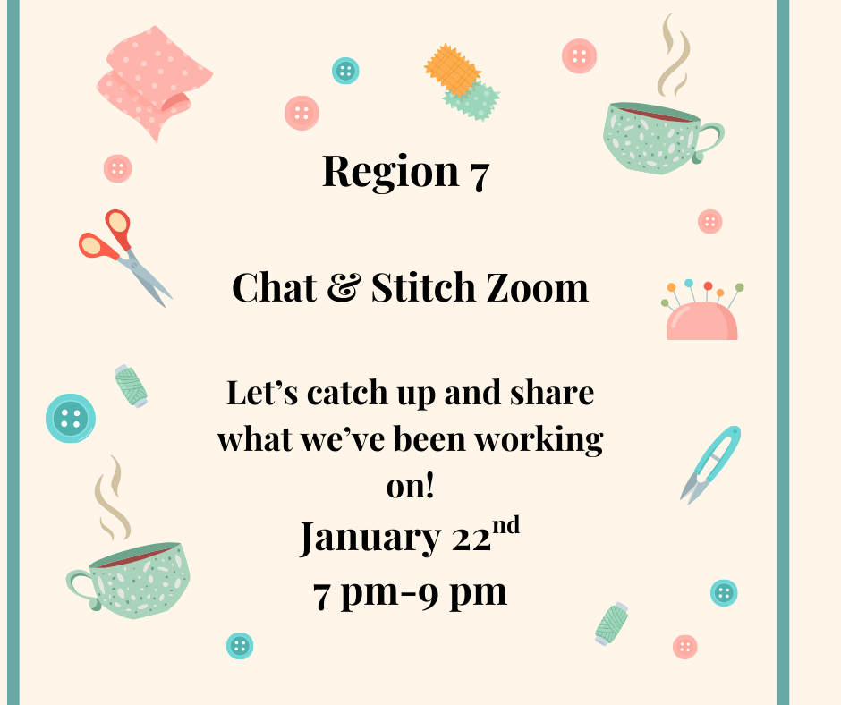
Did you go to the Guild's online retreat? What did you enjoy? Share your stories!
Also - let us know your favourite quilting accessory (and your worst!)
Join us from 7pm.
Meeting ID: 851 4121 5422 Passcode: 858409

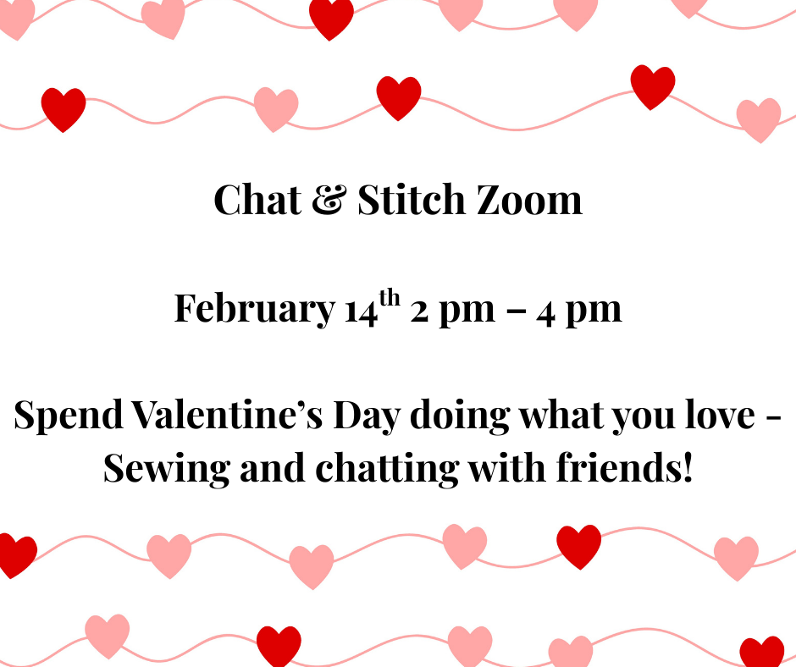
Show us all your Hearts & Red Quilts, on this Valentine’s afternoon.
Join us from 2 pm.
Meeting ID: 851 4121 5422 Passcode: 858409

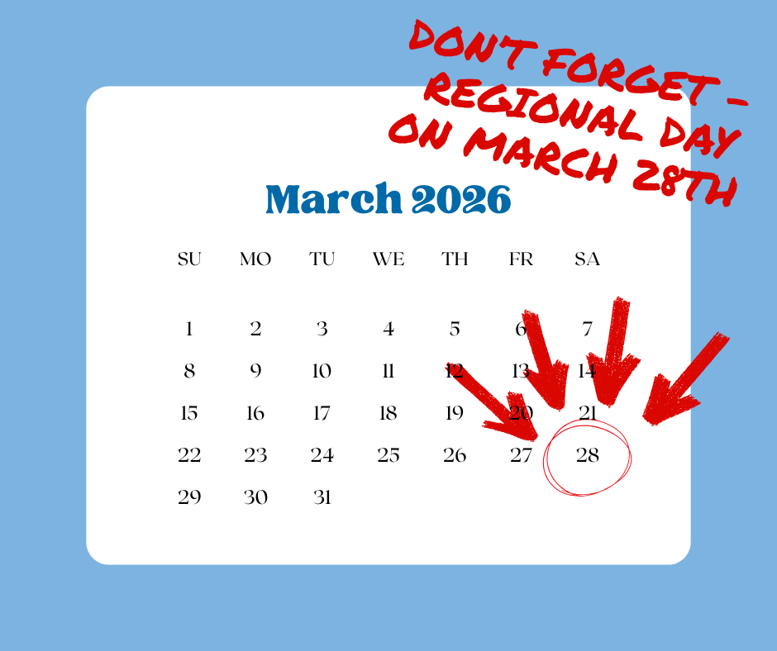
REGIONAL Day March 28th
10 am – 4 pm
Join us for what will be a fun day – We have the fabulous Sarah Humphreys coming along to give us a talk in the morning about her Quilting journey. She will be bringing lots of her award-winning quilts to show us.
After lunch Sarah will lead a hand-stitching workshop ‘Borrowed from Boro’, a modern interpretation of the traditional art of Boro.
As well as having a trader, raffle and Show and Tell. We also hope to have an exhibition of the Region 7 Sew along Quilts from 2025 and members quilts.
Book now to ensure a place
£30 members £45 non-members
More information and booking details can be found by clicking this link.

Other events: Shows:

Grosvenor – Newark Quilting and Sewing Show 16th to 17th Jan
Grosvenor- Ardingly Quilting and Sewing Show 29th Jan to 31st Jan
Grosvenor- Newmarket Quilting and Sewing Show 26th to 28th Feb
Link for more information for all Grosvenor shows here.
The Stitch Festival
Business design Centre, Islington, London
March 19th - 22nd
Book tickets (with a £2 discount using code QGD26) here.



Other events: Exhibitions:

A Culture of Colour: Annie Folkard exhibition of Contemporary quilts
The Horton Arts Centre, Haven Way, Epsom KT19 8NP
9.15 - 4.30 Tues – Sat
Free entry
Freedom of expressions Contemporary Textile Art by CQ Surrey
20th- 25th Jan - Art Gallery at Denbies Wine Estate, London Rd, Surrey RH5 6AA
9.30 - 5.00 daily
Free Entry
The Art of Tiny Stitches ‘Sew Dainty’ and exhibition by the Embroiderers Guild
10th Jan to Dec 2026 - Bucks Museum, Aylesbury HP20 2QP

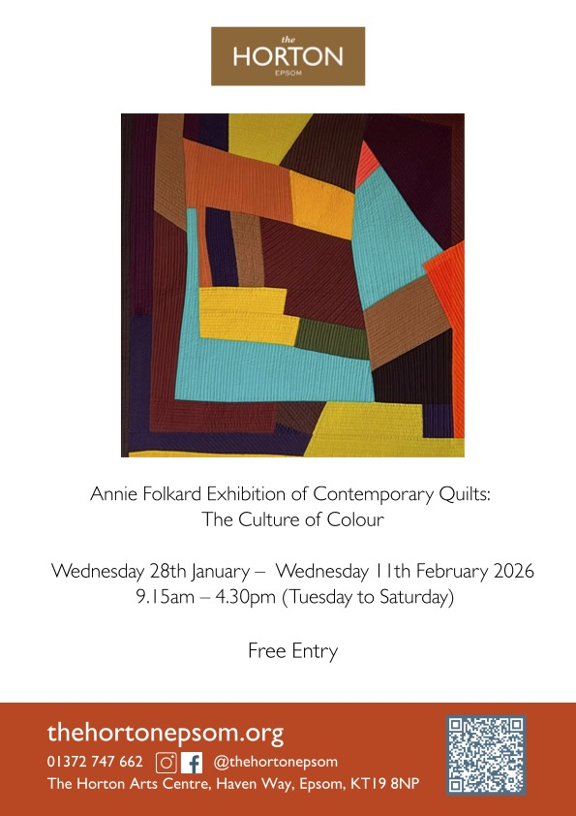

Other events: Talks:

Keene Quilters, in Region 8, hold talks online. All are welcome to attend!
They have Alexandra Kingswell booked for 23/02/26
For full details, contact keenequilters@outlook.com
The Guild website has lots of information on events in all regions-www.quiltersguild.org.uk/pages/events-and-exhibitions
Here is a link to the groups we have in Region 7
If your group would like to advertise a talk, workshop or exhibition please contact Reg7@quiltersguild.org.uk with details (or reply to this email)
We would love to hear from you… please send any photos/ articles, to reg7@quiltersguild,org.uk

Click here for the latest Young Quilters newsletter

Click here for the latest Young-ish Quilters newsletter

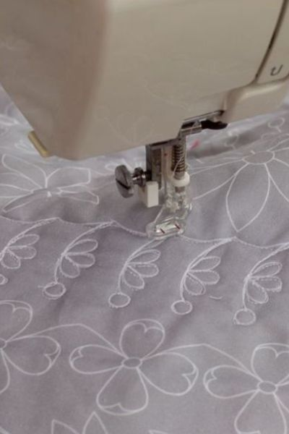
Quilting projects

Visit our online shop

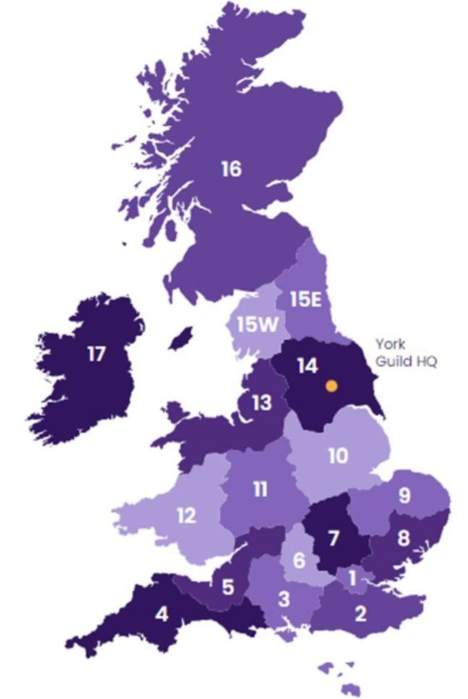
My local Guild

Visit your Region's web pages

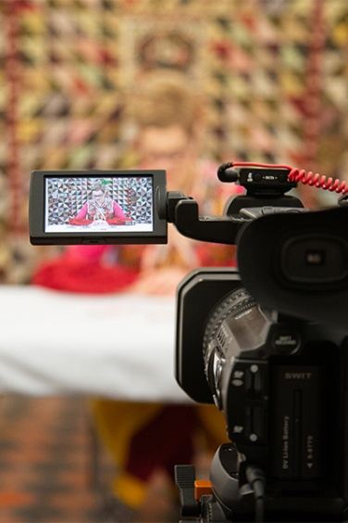
Exclusive videos

Watch and learn online

Want to change how you receive these emails?
You can update your preferences or unsubscribe from this list*.
*Please note, if you unsubscribe, you will no longer receive any emails from The Guild, your region or special interest group, which would be a shame.









Copyright © 2026 The Quilters' Guild of the British Isles, All rights reserved.
You're receiving this as a member of The Quilters' Guild or because you have opted in to receive our newsletters.
Our mailing address is:
The Quilters' Guild of the British Isles
St Anthony's Hall
Peasholme Green
YORK, North Yorkshire YO1 7PW
United Kingdom
Add us to your address book

