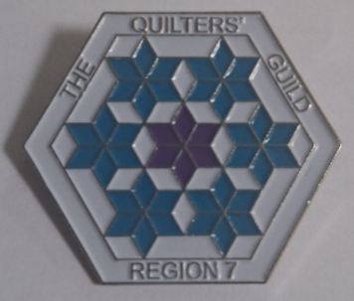
The Finishing Stitch

April 2026

A Message from our Coordinator-
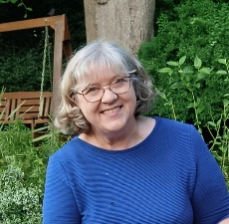
It was so lovely to meet you all at the recent Regional day in Herts. I’m sure you’ll agree it was a most enjoyable day, with lots of quilts, chat and stitching.
Over the past few months your committee has been busy planning lots of different events, from visits to exhibitions and Historic Houses to new quilting workshops. Full details of our events can be found in this newsletter, on our events page of the Guild’s website and on our Facebook page. We’d love to hear for you about workshops and social events you would like us to organise. If your Quilting group has an exhibition, speaker or workshop you’d like more people to know about, send me the information and we can advertise it across the region.

Have you ever considered joining the regional committee?
We currently need a Newsletter editor. This role involves putting together the newsletter from articles sent. You don’t have to write the articles – just put them into a logical order. Please get in touch if you’d like more information on what is fully involved in this role.

So, grab a cuppa, sit back and enjoy reading about what is happening across Region 7.

Happy Quilting Alison

What’s coming up …
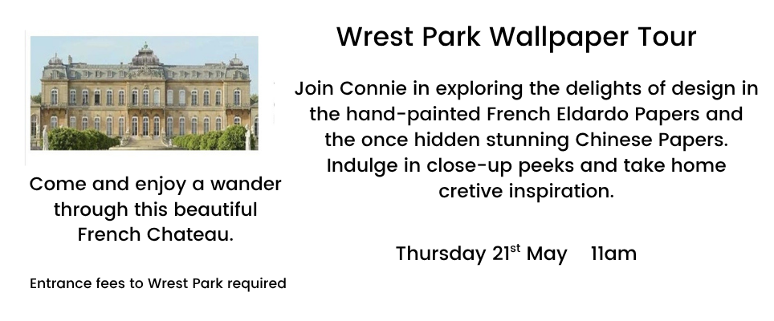

21st May
TBC

Contact Connie Bedford@quiltersguild.org.uk to book your place

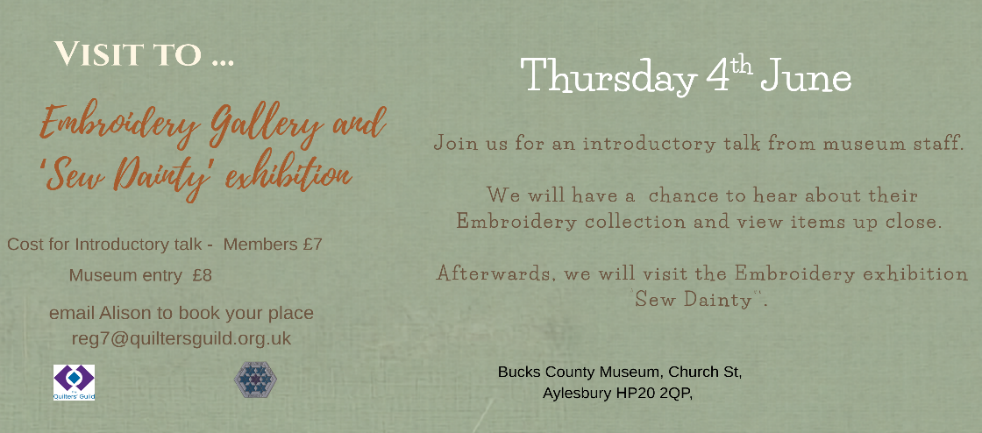

4th June

Contact Alison Reg7@quiltersguild.org.uk to book your place

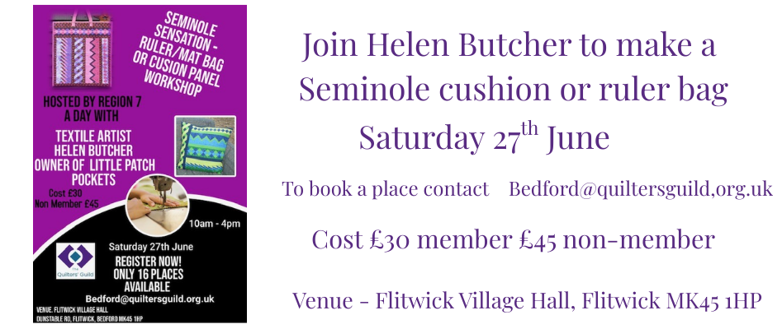

27th June

Contact Connie Bedford@quiltersguild.org.uk to book your place

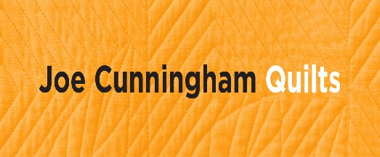
Save the Date -:
26th September – In-person workshop with Jo Cunningham, a well-known American Quilter. Only have 20 places available. Full details available soon-
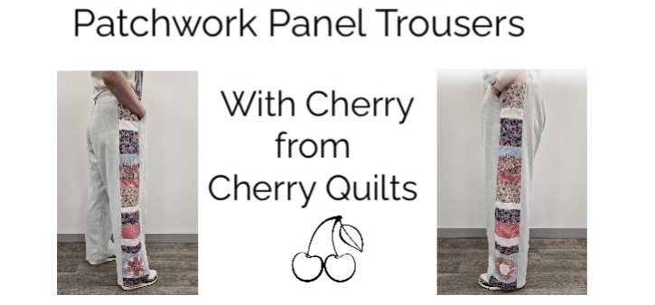

17th October workshop

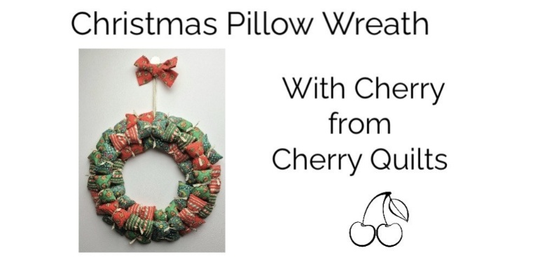

28th November workshop

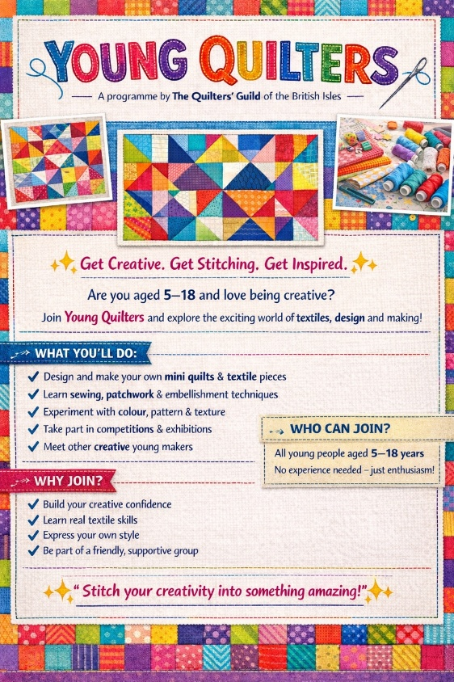

Young Quilters
A big thank you to everyone who purchased a raffle ticket at the recent Hertfordshire Regional day. The funds raised [£216] will go towards supporting our Young Quilters.

Festival of Quilts 2026

Do you know any Young Quilters who may be interested in entering a quilt into this year’s Festival of Quilts? Young Quilters no longer have to follow a theme. However, the optional theme is ‘Celebration’, if entrants wish to follow it.
Celebrations and festive rituals vary depending on the occasion, where you live and your culture. It might be a particular date, a religious festival, a sporting achievement, celebrating an important milestone or another achievement you are proud of. Think creatively!

Quilts entered by Young Quilters can be of any size and use any technique. There are three age categories for the entries:
a) 5 – 9 yrs b) 10 – 13 yrs c) 14 – 18 yrs

Please get in touch ….
If you know of any young people aged between 5 to 18 years who would be interested in being a Young Quilter (aged 5 to 12 yrs) or a Youngish Quilter (aged 13 to 18 yrs), or you are able to support our Young Quilters in any way.

Cara (YQ Coordinator Region 7) yq_reg7@quiltersguild.org.uk

Review of events…

Herts Area Day: Wheathampstead, March 28th 2026
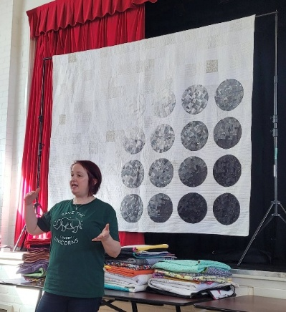
Talk and workshop by Sarah Humphreys
https://www.instagram.com/edwardandthewhitebear/
A very enjoyable day was had at Wheathampstead on
March 28th. With an attendance approaching 50, the hall was
buzzing with chat, fabric sales and cake eating. However, once
Sarah began her talk, silence fell as we were all absorbed by
her delightful story and amazing abundance of quilts.
Just a few of which are shown below –
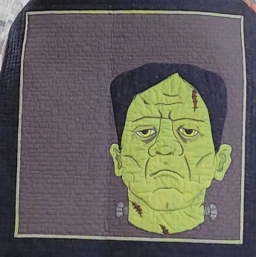
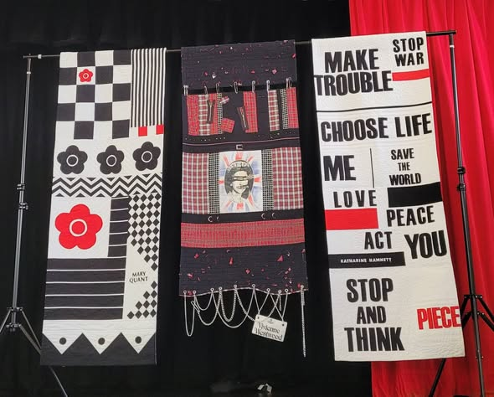
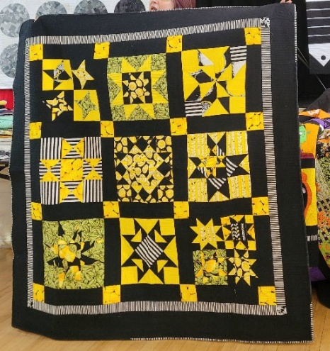

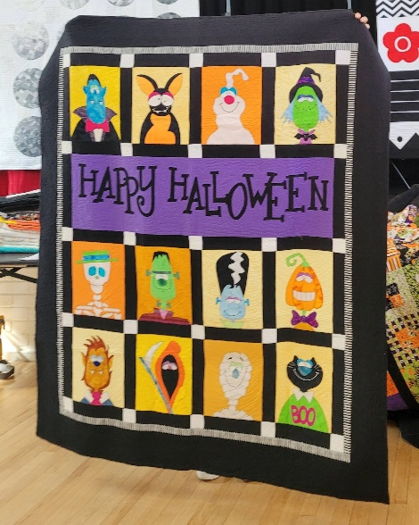
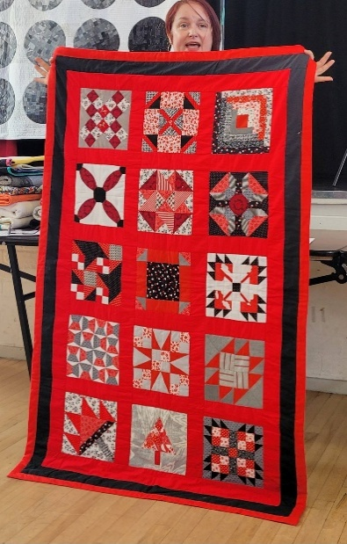

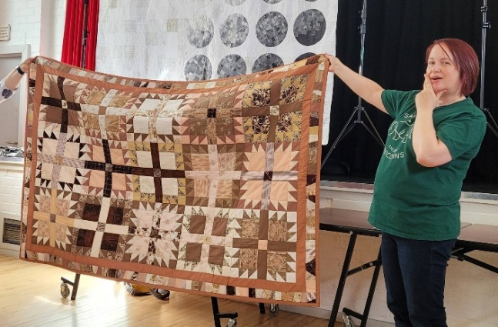

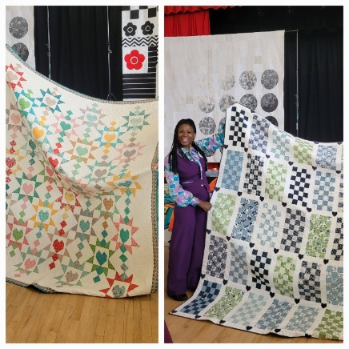
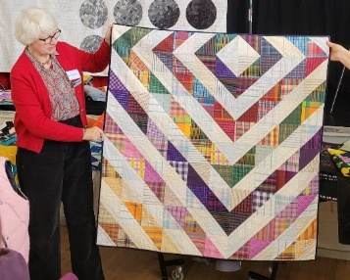
In the afternoon we applauded some beautiful show-and-tell work. Here are just a few photos. You can view all the lovely Show and Tell quilts on our regional website -Gallery page https://www.quiltersguild.org.uk/regions/region-seven/gallery

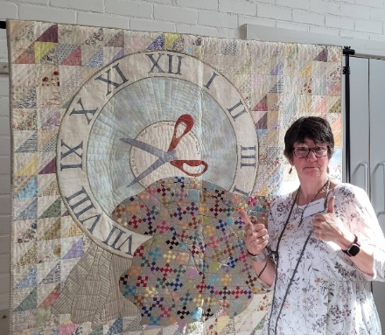

A huge thank-you goes s to Mary Mayne for donating a wonderful quilt for the raffle. Here is the lucky winner, Valerie with the quilt. We raised £216 for Region 7 Young Quilters

After that the hall fell quiet again as we all listened to Sarah explained that the technique of ‘boro’ has developed from the Japanese art of patching clothing with decorative embroidery. We ironed plain and coloured fabrics onto interfacing and then embroidered over the top. Lots of chat and stitching then followed. A very enjoyable, relaxing afternoon was had by all
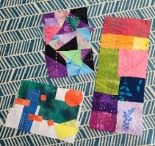
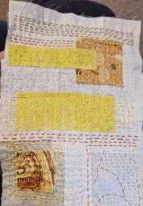
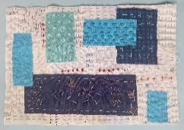
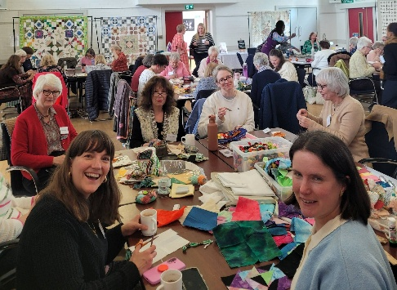

Thanks goes to -:
Simone at ‘Fashion n Fabrics’ for being our trader
Mead Quilters for providing delicious cakes and refreshments
Ginny Edwards for running our charity donation stall which made £170 for the charity ‘Comfort Cases UK’ who support children in foster care in the UK.
https://comfortcasesuk.org/
Also thank you to everyone who attended and made it such a happy and productive day.
Jennie Barwise Herts Area Rep
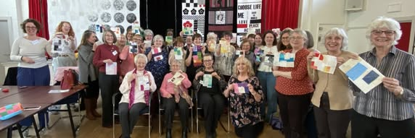

STARS workshop – 13th March
On the 13th March, Members had a lovely sunny day at the North Crawley Institute getting to grips with making a "Triangle of Stars" with Andy and Jo from Crafty UK.
When the bags were dropped, we could not stop ourselves from the delights of the new season of fabrics from the pop-up shop Andy and Jo brought along with them. Bundles, Fat Quarters and Bolts. I wanted them all !
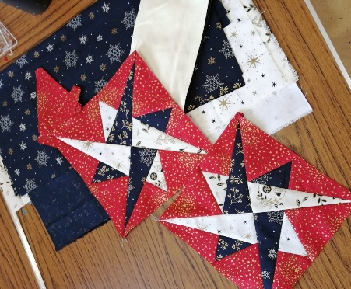
Anne Goodwin brought along a yummy cake to accompany our morning cuppa, which pretty much promptly disappeared! Much enjoyed Anne, thank you.
Once settled, Andy and Jo gave us each a box of templates to work with and after quick demo we all got started on cutting out the various shapes required. Then came that tricky bit where you have to sew all the bits together in the right order to build your stars. Andy and Jo were soon at your shoulder with help and advice. However, the chances of me putting fabric in the right order without unpicking a few times is pretty much zero and a hundred per cent due to my inability to stop nattering and enjoying the company around me! Pleased to say, I was not the only one with seam ripper in hand !
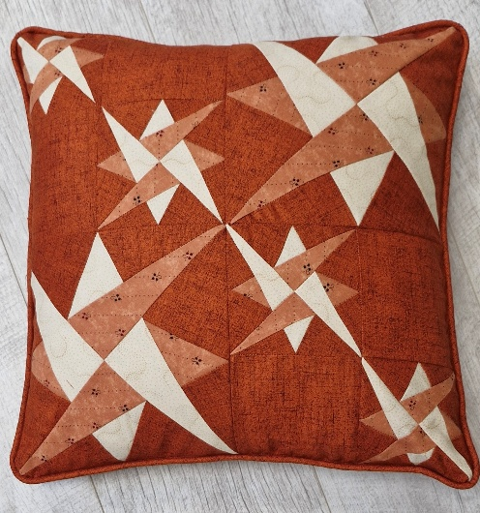
Eventually, our tummies rumbled and we called a halt for lunch. This led to a lovely extension of a break with a marvellous show & tell from Andy & Jo, which showcased their templates and applique patterns to perfection. Leading to another round of shopping!
The afternoon flew by as we got to grips with how the blocks are constructed and joined together, then all too soon it was time to head for home.
Overall, a lovely day of companionship and learning "Go our Lovely Guild "
With Stars in her eyes.. Connie [bedford@quiltersguild.org.uk]

Star Cushion by Janette

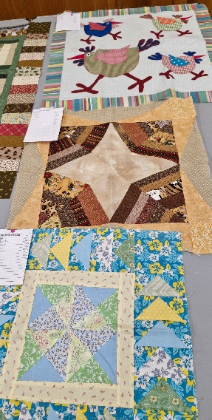
Gretton Quilting Group- Round Robin
Over the last few years, we have had some form of group activity on our agenda. This year we have a Round Robin. Currently 13 people are taking part. In January each person brought a block to the monthly meeting. There were no rules for this – any size or shape was accepted – thankfully no triangle shaped blocks! Each block was passed onto someone else to add more to it. This could be another block, a complete border or, just adding to one or more sides. The blocks returned in March ready for the next round. The photos show the blocks so far and are due back in May. We have followed some of the general ideas of a round robin. It seems that in some groups you do not know who did the previous rounds but we haven’t hidden this information. We don’t know who our next block will come from or go to until the meeting and there is definitely some trepidation felt when looking at those on offer and wondering which you might be given – will I have the right colours? How can I add to that?
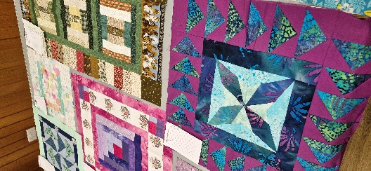
We recently found an article in a 1995 issue of Popular Patchwork which explained the premise of a round robin and gave some great ideas for adding to the blocks.
The plan is to keep going for the year – so that will be 6 rounds in all as we swap bimonthly. Our main aim is that no one feels stressed by the activity – so missing a session is fine, and others can join in if they wish. Our final quilts will be quilted by Emma at Quilters Trading Post, who is a group member, and donated to charity – Project Linus and Quilts for Care Leavers. I’ll try to post some more pictures of our progress and of the final quilts.
Janette Hall Gretton Quilting Group, and Northants Area Rep

Display of Quilts at St Albans Cathedral on 8th December 2025
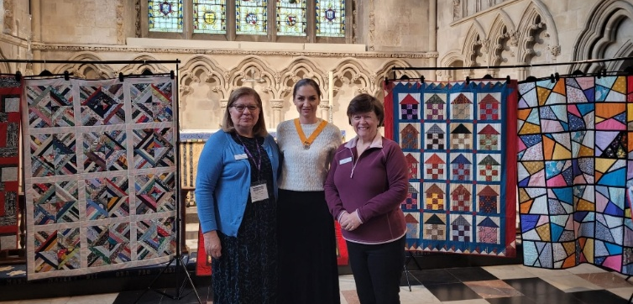
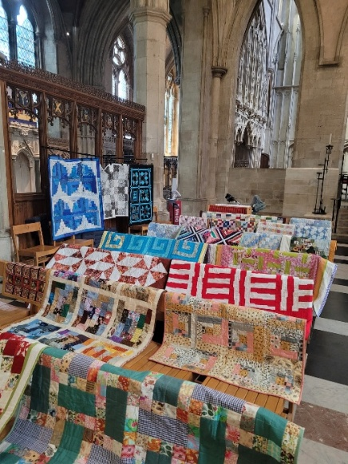
An amazing array of over 180 quilts of all shapes, sizes and hues were on display in the Lady Chapel at St Albans Cathedral on Monday 8th December. All of these quilts were destined to be donated to various groups and charities across the county before Christmas. This is thanks to the inspiration and hard work of two quilters in the county.
In 2020, Caroline Ellis and Ginny Edwards started working with quilt makers in Hertfordshire to provide quilts and other handmade gifts for those in need. What started out as a small idea to keep them occupied during the pandemic, has turned into a fantastic annual project to support many charities with clients that need a warm quilt hug. These include the Women Refuge in St Albans and Hertsmere, Children Services in Hertfordshire, West Hertfordshire Teaching Hospitals NHS Trust, Up to Downs, and other local charities. It brings comfort and joy to many women and young people who are homeless, have escaped domestic violence or circumstances where they are not able to stay in their own homes.
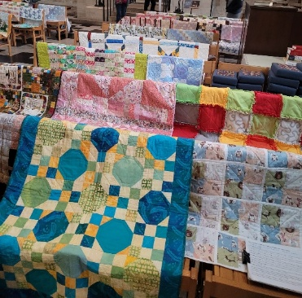
Quilts were made by several local quilting groups such as Mead Quilters in Wheathampstead and Connecting Threads in Elstree and through the Linus quilt project. The exhibition was a great success and attracted a lot of visitors including several local mayors, who received quilts on behalf of the charities in their areas.

Region 7 Sew-along Quilts- Jan – June 2025
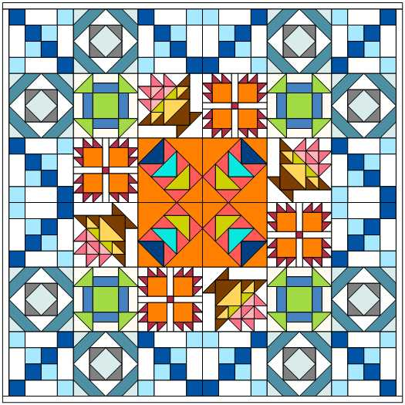
The Sew-along was about having fun and not about perfect points; it was about the love of fabrics, colour and design.

We selected 6 blocks, that we believe would be achievable for everyone.

Participants did not have to stick to the design and were free to pick and mix the blocks in any quantities and placement that they would like.

Monthly zoom meetings were held where we were able to see how everyone was getting along, have a chat about any tricky bits, and do a bit of show and tell.

Photos of 9 of the Sew-along quilts can be seen in our Gallery on the website – as a taster here are a few to whet your appetite! https://www.quiltersguild.org.uk/regions/region-seven/gallery
Congratulations to everyone who took part – well done!
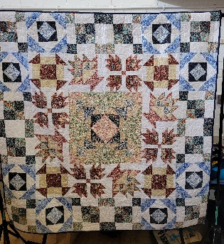
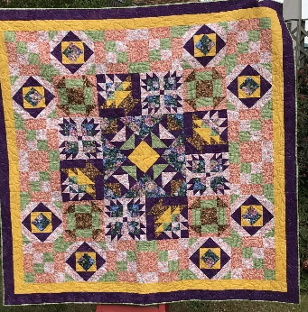
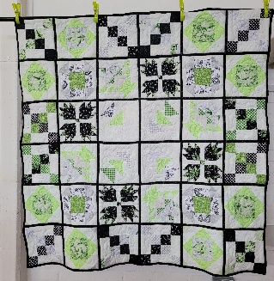
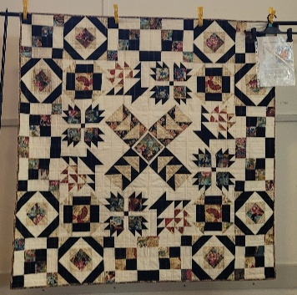

Quilts by Connie, Sharron, Geraldine and Rose – for more detailed photos of all 9 quilts go to the Gallery page on the region 7 section of the Guild’s website

A look round the region…
what have the groups been doing this year?
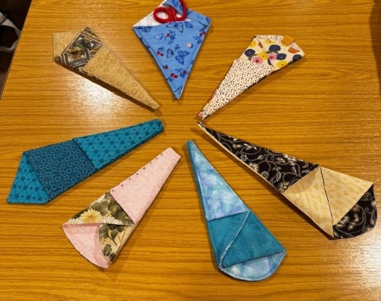
Kempston Quilters
Kempston Quilters had a fun Easter Scissor Case swap. The next swap is a summer themed mug cosy for their Strawberry Tea in July.
Kempston Quilters host Sew Social Saturdays
If you would like to join them one Saturday contact Connie to book
At Bedford@Area Rep Bedford
4th April 2nd May 6th June 25th July 26th September 24th October at
Kempston Town Council Chamber Room, 104 Bedford Road MK42 8BG

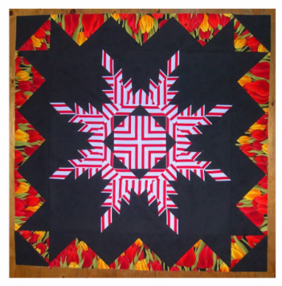
Mead Quilters
January 2026 : Joint Zoom with Mimram and Icknield Quilters. Carolyn Gibbs, Success with Stripes
Welcome to Carolyn Gibbs Quilts : Carolyn Gibbs Quilts
Who knew that there were so many things to consider when using striped fabric in quilting? Carolyn’s very professional online presentation considered not only the orientation of the stripes but the size, style and symmetry of the pattern as well. She gave us lots to think about and some useful tips as well.

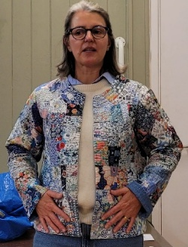
February 2026: Megan Manwaring. An Australian Quilter, passionate about all things patchwork, quilting and textiles.
Megan Manwaring (@meganmanwaring) • Instagram photos and videos
Megan gave us a great talk with an absolutely stunning display of amazing quilts. A most inspiring meeting. Here she is in her lovely, quilted jacket.

March 2026: Sara Sullivan, My Hexagon Journey
- a personal journey of English Paper Piecing. https://www.quiltersguild.org.uk/blog/please-touch-creating-an-accessible-quilt-exhibition
Sara gave us a very amusing talk about her obsession with hand pieced hexagons. She showed us some historic pieces and lots of her own work.

If you’d like to show us what your group has been doing … then let us know! Email Alison reg7@quiltersguild.org.uk

Website and Facebook Page
The Region 7 section of the Quilters’ Guild website has all our event information and lots more…
Details of Quilt Groups in Region 7 can be found on the ‘Groups’ tab on the website -:
Contact details for the committee members are on the website.
Don’t forget that we have a Regional Facebook page, that is open to all our quilters – yes, members and non-members. There are a few questions to answer to make sure that you are not a scammer when asking to join. We are a fun group, sharing photos, events, exhibitions. Why not join.
www.quiltersguild.org.uk/regions/region-seven
www.facebook.com/groups/696727447129587
and you can find us on Instagram …
If you have an Instagram account, give us a follow to stay up to date with all our events and
shows. If you enjoy sharing your quilting photos and stories, tag us on #qgbiregion7.
Let’s celebrate our quilting journeys together.
Don't forget that this is YOUR newsletter, so please send us photos and items of interest for our regional community

Happy Quilting from the region 7 team

